

**CS6004ES-Application Development Coursework 2 Submission–Main Sit (2017/18)**

**Thilina Thushantha**

**LMU ID – 17032498**

**LMU SE/Batch 09**

**Acknowledgement**

I would like to convey my sincere gratitude to Mr. Erandika for supporting me throughout this entire module & for sharing his valuable knowledge with me.

As well as I would like to express my gratitude towards my batch mate friends for their kind help and encouragement. Also I would like to express my gratitude toward my family and friends for their help in the completion of the assignment.

Table of Contents

**1.0 Introduction** 6

**1.2 Functional Requirements** 7

**1.3 Non-Functional Requirements** 7

**2.0 What is Workflow** 8

**2.1 What is the importance of a workflow** 8

**2.2 Advantages of Workflows** 8

**3.0 Use Case Diagram** 9

**3.1Use case narration** 10

**4.0 Class Diagram** 11

**5.0 ER Diagram** 16

**6.0 Software Architecture** 17

**7.0 Installation Guide** 18

**7.1 Installation and Configuring Procedure** 19

**8.0 User Manual** 20

**9.0 own reflection of own experience** 26

**10.0 Reference** 27

**Table of Tables**

Table 1 - EmployeeModel 14

Table 2 WorkFlowModel 14

Table 3-EntityModel 15

Table 4- StatusModel 15

Table 5 - OrganizationModel 16

**Table of Figures**

Figure 1 - Use Case Diagram 10

Figure 2 - Class Diagram 12

Figure 3 - ER Diagram 17

Figure 4 - User Management 22

Figure 5 - Edit User 22

Figure 6 - Create User 23

Figure 7 - Create Work Flow 23

Figure 8 - Create Work Entity 24

Figure 9 - Assign Work Entity 24

Figure 10 - Assign Manager 25

Figure 11 - Processing Work Entities 25

Figure 12 - Main Work Flows 26

# **1.0 Introduction**

In the pioneering years of automation, businesses put IT in complete control of workflows and everything around it. Digital workflow successfully replaces manual processes by automating hand-offs and other repetitive tasks, that can be completed without human intervention. Workflow are usually automated with workflow management tools that allow setting business rules to dictate when one step can be taken as successfully completed and the next step can be triggered. In today’s market, a workflow management system finds many takers when it has the required features.

XYZ is one of the company which currently using manual process to done their work. Within this project we are going to introduce automated workflow system for the XYZ Company.

XYZ Pvt Ltd is a company has a business requirement to manage various documents through their workflow cycle in several stages and with several access levels.

From this project we are going to introduce a system which can handle their all function requirements and non-functional requirements as well as domain requirements.

## **1.2 Functional Requirements**

* Only registered users can log to the system.
* Admin can add employees to the system and an update and delete them.
* Mangers can be able to create, read, update and delete workflows
* Managers can be able to create, read, update and delete entities
* System should be able to store workflows of which age is less than 5 years.
* System should have archiving facility to archive workflows more than 5 years old
* Users must be granted access to all the above functionalities depending on their type.
* Admin should be able to change the workflow ownership.

## **1.3 Non-Functional Requirements**

* User authentication and authorization
* Maintain data integrity
* System must provide user friendly user interfaces
* System functionalities must be easy to use and simple

# **2.0 What is Workflow**

Workflow is a set of tasks that processes a set of data. Workflows are used across every kind of business and industry. Any time data is handed back and forth between humans and/or systems, a workflow is created.

Workflows have three essential qualities.

1. They must be a predictable progression of steps.
2. They must be repetitive.
3. They must involve at least two people.

When it comes to the automatic, a system takes responsibility for managing the flow of the tasks including notifications, deadlines, and reminders. In an automated workflow, when a human or system completes a task, he is not responsible for passing the data on to the next task. The workflow automatically handles this.

## **2.1 What is the importance of a workflow**

By measuring the work that needs to be done, you can optimize the time period of a particular task. Otherwise it is difficult to gain an idea of what is going on or what work to be done to accomplish.

## **2.2 Advantages of Workflows**

1. Eliminate redundancies
2. Improve efficiency
3. Enhance delegation of tasks
4. Sequentially approach operations
5. Improve coordination and facilitate faster turnaround times
6. Facilitate greater visibility of progress
7. Establish accountability

# **3.0 Use Case Diagram**

**Work Flow Management**

Figure 1 - Use Case Diagram

## **3.1Use case narration**

**Use case name:** Work Flow Management

**Primary Actor:** Employee

**Secondary actors:** Admin, Manager

**Normal flow of sequence:**

1. Login / Logout
2. Registration
3. Add,Edit,Delete(Employee)
4. Tasks
5. Archiving

**Alternative flow of sequence**

1. If the user name and password are wrong, system should have facility to show error message.

**Pre-conditions:**

* Any user must have a username and a password to login to the system

**Post-Conditions:**

* All Details are store into the database

# **4.0 Class Diagram**

We have created the classes, Properties, Methods as bellow.

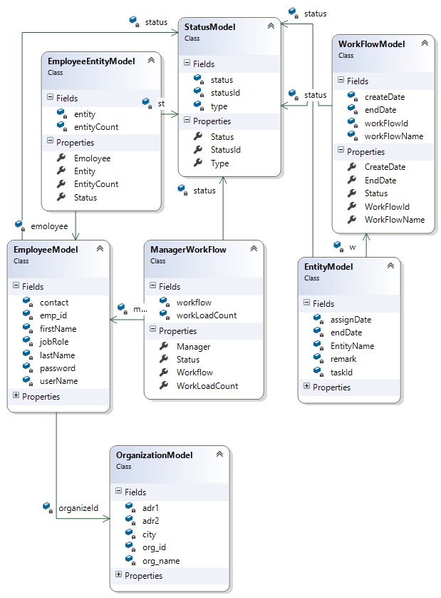

## 

Figure 2 - Class Diagram

**EmployeeModel Class**

Within this class it will display all the user types. Following user types are used in this system.

* Manager
* Administrator
* Employee

Those the attributes we defined under employee class.

|  |  |
| --- | --- |
| ***Property/Method*** | ***Description*** |
| contact: string | This is mandatory field and it is in string data type. This can be duplicated within the system |
| emp_id: int | This ID is auto generated when an entity is created. Every entity has a unique ID and the data type is Integer |
| firstName: string | firstName is mandatory field and it is in string data type. This can be duplicated within the system |
| jobRole: string | This is mandatory field and it is in string data type. This can be duplicated within the system |
| lastName: string | This is mandatory field and it is in string data type. This can be duplicated within the system |
| Password: string | When registering users Admin will assign password to the users. Password length is 10 and in string data type. |
| username : string | When registering users Admin will assign password to the users. Password length is 10 and in string data type. |
| Create() | Only admin will allow to create and save user by filling all the mandatory fields. |
| Edit() | Only admin will allow to edit and save user details. |
| Delete() | Only admin will allow to delete users. |
| GetPermission() | Only registered users can log in to the system |

Table 1 - Employeemodel

**WorkFlowModel Class**

|  |  |
| --- | --- |
| ***Property/Method*** | ***Description*** |
| createDate : DateTime | This is the workflow created date. The data type is datetime. |
| endDate: DateTime | Holds the date of which the work flow is closed. The data type is datetime |
| workFlowId: int | Work flow Id is auto generated and data type is integer. |
| workFlowName: string | This is a mandatory field. The data type is string. This is user for identify the workflow. |
| Create() | By using this method only manager can create the workflow. It will generate a record for the workflow. |
| Edit() | Manager will allow to edit and save user details. |
| Delete() | Manager will allow to delete users. |
| workLoadCount () | This will count the work load of the Manager |

Table 2 WorkFlowModel

**EntityModel Class**

|  |  |
| --- | --- |
| ***Property/Method*** | ***Description*** |
| assignDate : DateTime | This will be the stat date of the entity. |
| endDate:DateTime | This will be the end date of the entity. |
| entityName: string | This is mandatory and in string data type. |
| remark: string | This is mandatory and in string data type. |
| taskId: int | Task Id is auto generated and data type is integer. |
| status () | When the workflow is on the process by using this method it will identify the current status. |
| entityCount () | This will be count the entity |

Table 3-EntityModel

**StatusModel Class**

|  |  |
| --- | --- |
| ***Property/Method*** | ***Description*** |
| status : String | This will having the all possible status of employees |
| statusId : int | Work flow Id is auto generated and data type is integer. |
| type : string | This will having the all types of the status of employees |

Table 4- StatusModel

**OrganizationModel Class**

|  |  |
| --- | --- |
| ***Property/Method*** | ***Description*** |
| adr1: string | This is mandatory field and it is in string data type. This can be duplicated within the system |
| adr2: string | This is mandatory field and it is in string data type. This can be duplicated within the system |
| City: string | This is mandatory field and it is in string data type. This can be duplicated within the system |
| org_id:: int | Org Id is auto generated and data type is integer. |
| org_name: string | This is mandatory field and it is in string data type. This can be duplicated within the system |
| Create() | By using this method admin can create the Organization |
| Edit() | Manager will allow to edit and save Organization details. |
| Delete() | Manager will allow to delete Organization. |

Table 5 - OrganizationModel

# **5.0 ER Diagram**

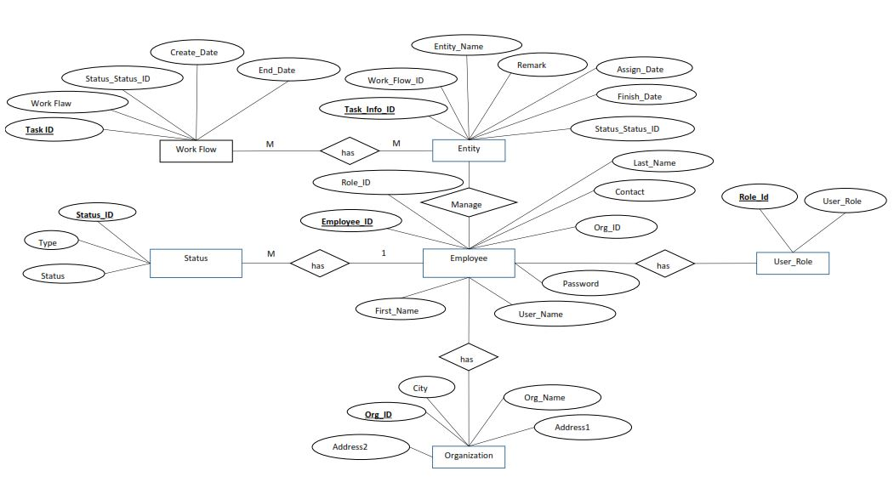

Figure 3 - ER Diagram

# **6.0 Software Architecture**

To develop this application we used MVC architecture.

When we using this architecture there are 3 main components. Simply MVC separates the application into three components.

That three components are:

* Model
* View
* Controller

**Model**: Model represents shape of the data and business logic. It maintains the data of the application. Model objects retrieve and store model state in a database.

**View**: View is a user interface. View display data using model to the user and also enables them to modify the data.

**Controller**: Controller handles the user request. Typically, user interact with View, which in-turn raises appropriate URL request, this request will be handled by a controller. The controller renders the appropriate view with the model data as a response. For this project MVC architecture is used.

When the user type or enter a URL in the browser, it goes to the server and connect to the requested controller. Then, the Controller uses the appropriate View and Model and creates the response and sends it back to the user

# **7.0 Installation Guide**

**Introduction**

This is the installation guide for a web-based document management system for XYZ Pvt Ltd. This system is handling the various documents through their workflow Cycle.

Pre-Installation Requirements:

**Database Prerequisites**

* SQL server 2012 R2 or above

**IIS Requirements**

* IIS 6 or greater
* NET 4.5 enabled

**Hardware Requirements**

**Minimum Hardware Requirements**

* Processor: intel ® Core ™ i5
* Processor speed: 2.30GHz 2.40GHz
* Random access memory (RAM): 4.00 GB
* Hard disk capacity: 500 GB

**Recommended Hardware Requirements**

* Processor: intel ® Core ™ i5
* Processor speed: 2.30GHz 2.40GHz
* Random access memory (RAM): 4.00 GB
* Hard disk capacity: 500 GB

**Software Prerequisites**

* Microsoft® Windows Server™ 2003
* Microsoft .NET Framework 4.0
* Microsoft SQL Server™ 2010 or above

## **7.1 Installation and Configuring Procedure**

The installation procedure contains the following steps:

# Checklist Item

1 Configuration pre-requisites

2 Ensure that servers meet minimum hardware requirements.

3 Ensure that software prerequisites are installed.

4 Run the [product] installer program on the server.

5 Run the DB installer program on the server.

6 Install the database.

7 Import data

8 Configure API endpoints

9 Install Application Server

10 Install APIs

# **8.0 User Manual**

* By clicking the Login button following screen will pop up.

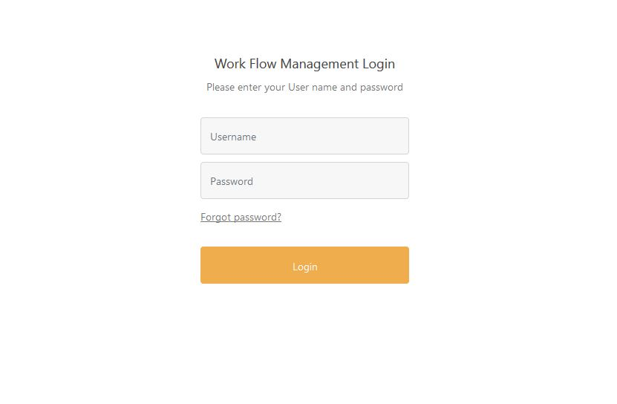

With this application we provided default administrator.

|  |  |
| --- | --- |
| XYZ |  |
| User Name | Password |
| admin | 123 |

After clicking on Login button with valid user details, Work Flow Management Dash Board will be displayed.

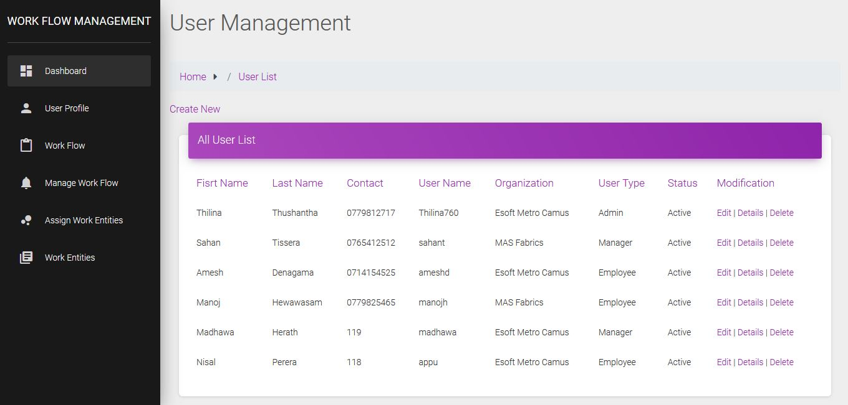

Figure 4 - User Management

By clicking on the User Profile it will load the registered employees list.

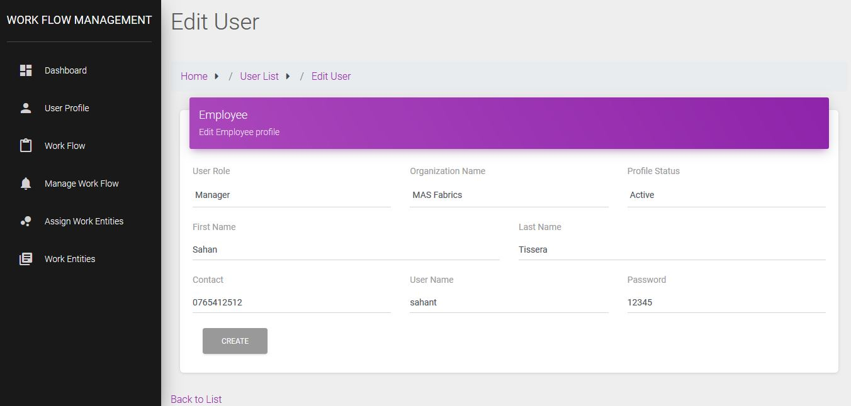

Figure 5 - Edit User

By clicking the edit button at the right side we can edit the existing user’s details

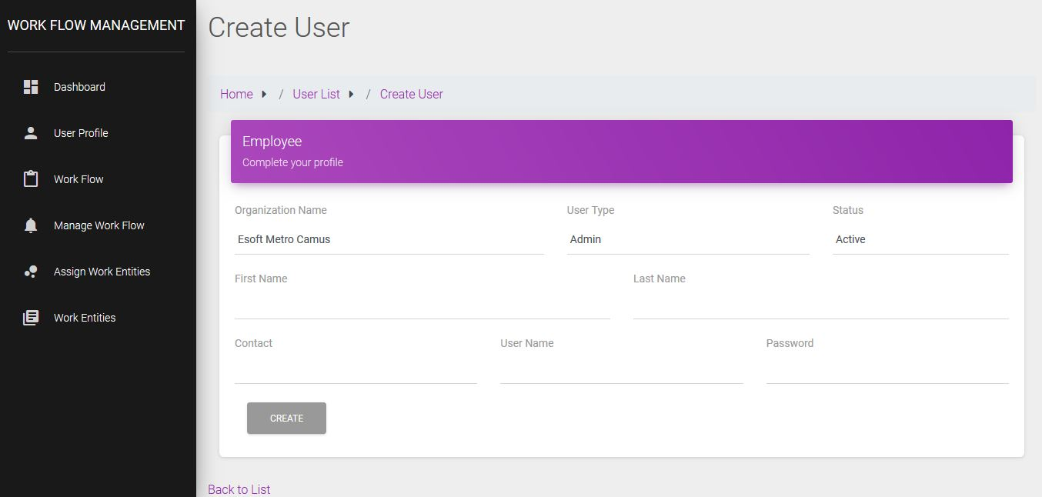

Figure 6 - Create User

* By clicking Create new button under the User Management screen we can load the Create User screen above.
* All the validation for the mandatory fields will be there.
* To create a User, Name and password is mandatory.

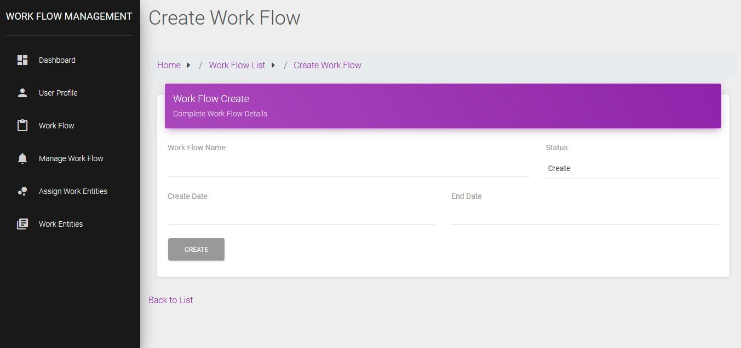

Figure 7 - Create Work Flow

Under the work flow, Manager can click the new button and create new Work flow and assign that to any user.

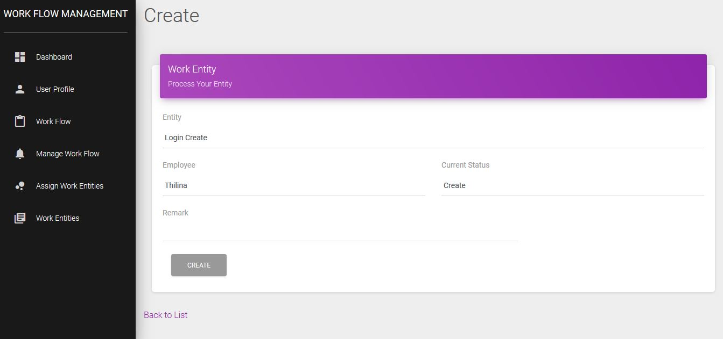

Figure 8 - Create Work Entity

Manager can create any entity from this window by giving particular entity, current status with employee

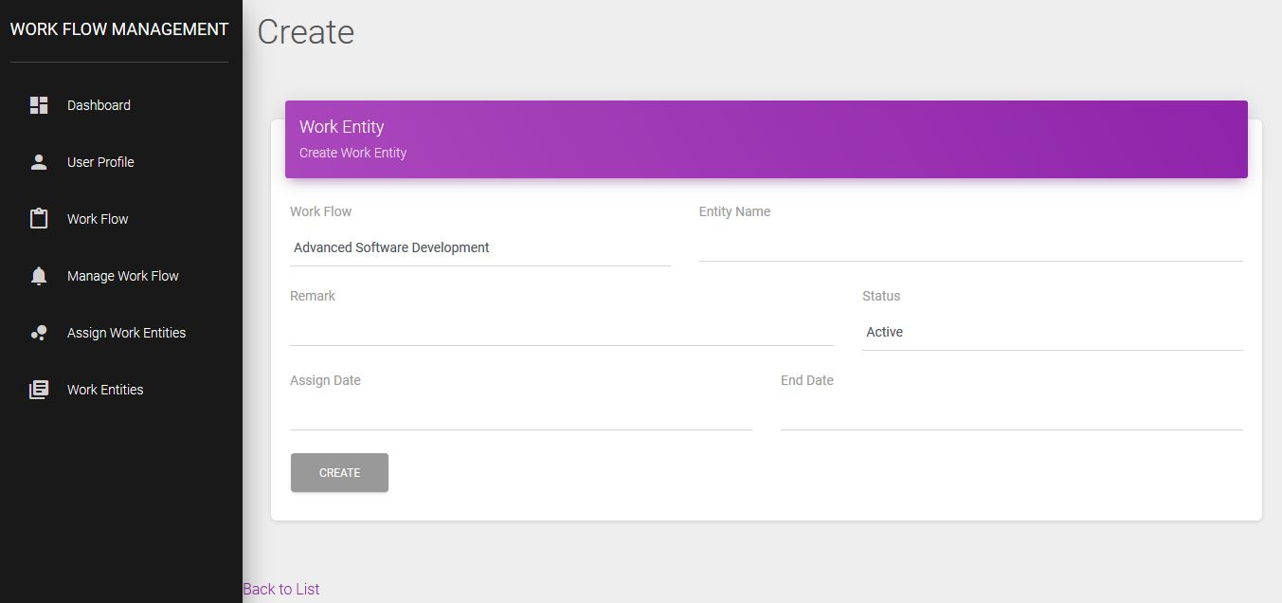

Figure 9 - Assign Work Entity

Manager can assign that particular entity to the work flow by using this window under the manage work flow.

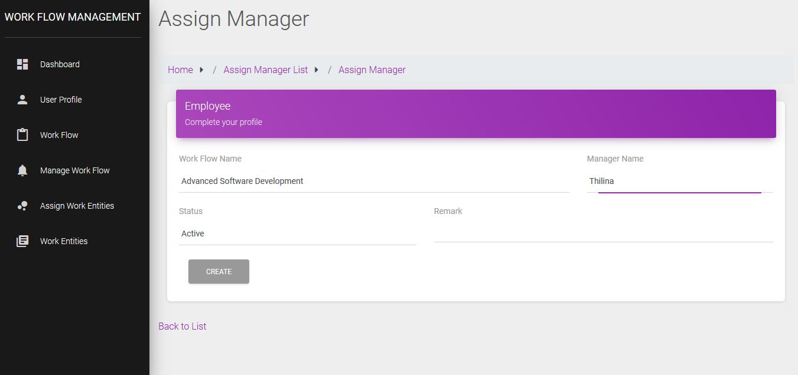

Figure 10 - Assign Manager

Admin can assign Manager to any work flow by using this window under the Assign work entities.

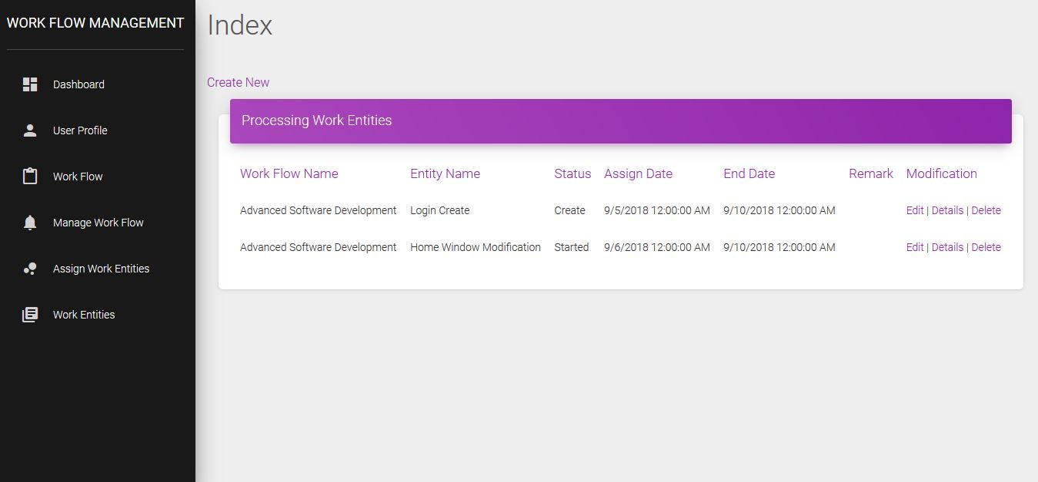

Figure 11 - Processing Work Entities

Manager can view the current situation of the work entities with Assign date and End date by using this window under the Work Entities.

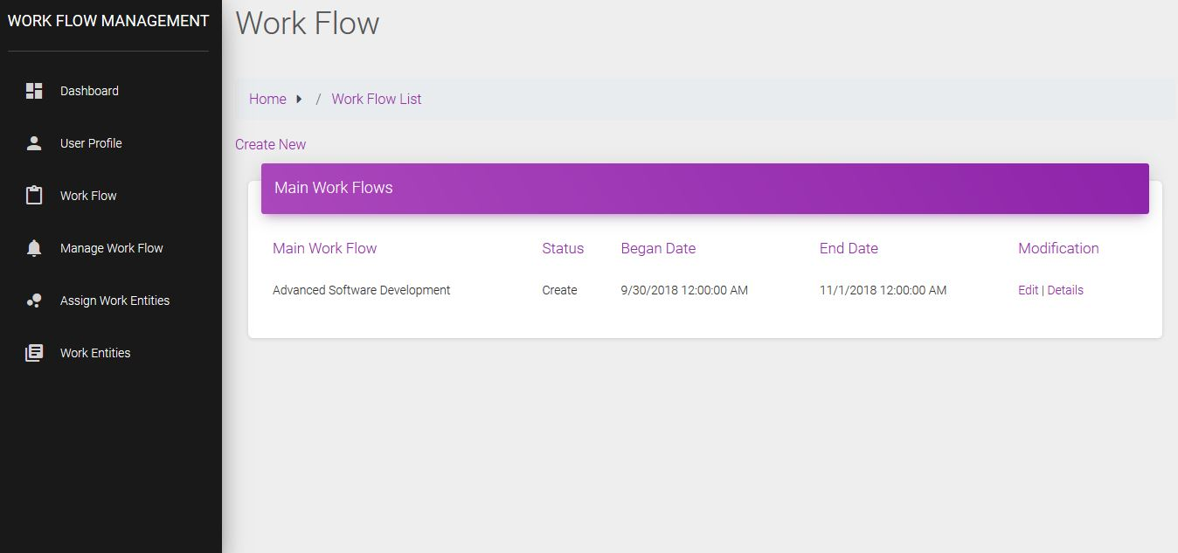

Figure 12 - Main Work Flows

Manager can view Main Work Flows with the Began Date and End date by using this window under the work Flow

# **9.0 own reflection of own experience**

From the starting point of this course work w have experienced lot of logical thinking points by drafting UML Diagrams, Class Diagrams & ER Diagrams. Before going to build the system we have to make sure all the required entities are included to the diagram and the correct order.

In this course we review the need for this clear communication. We discuss several of the common diagrams that we use to model a software solution and identify some of the diagram such as UML includes several diagrams and models that support the design of different aspects of the solution. If each member of the team is able to understand those models that are useful more likely to understand each other. So I understand that the challenges and risks of different understandings and views of the solution are minimized. By having this basic understanding of the diagram can reduce many of the challenges faced by any project teams.

Not only that when we talk about the developing part it was a challenge to develop this software with the newly learned MVC architecture, which is called Model, View, Controller. How ever the developing part was interesting for both of because of the curiosity of us to make this software better.

Finally the end product was satisfied us because our effort was successful than we thought within this short time period. We realize that was non other than our team work spirit.

# **10.0 Reference**

Lucidchart. (2018). UML Class Diagram Tool. [online] Available at: https://www.lucidchart.com/pages/landing/uml_class_diagram_tool?utm_source=google&utm_medium=cpc&utm_campaign=en_apactier1_desktop_nb_x_bmm&km_CPC_CampaignId=1521527704&km_CPC_AdGroupID=57991598373&km_CPC_Keyword=%2Buml%20%2Bclass%20%2Bdiagram&km_CPC_MatchType=b&km_CPC_ExtensionID=&km_CPC_Network=g&km_CPC_AdPosition=1t2&km_CPC_Creative=289080744949&km_CPC_TargetID=kwd335159025553&km_CPC_Country=1009919&km_CPC_Device=c&gclid=CjwKCAjw9sreBRBAEiwARroYmxh6QwaV65vQ5pjCad1IyZnyZe9kF63zs67kIljEHQFWlHgc_v4YKxoCoZUQAvD_BwE [Accessed 26 Oct. 2018].

Earl, L. (2018). MVC architecture. [online] MDN Web Docs. Available at: http://www.tutorialsteacher.com/mvc/mvc-architecture [Accessed 31 Oct. 2018].

Tutorialsteacher.com. (2018). *MVC Architecture*. [online] Available at: http://www.tutorialsteacher.com/mvc/mvc-architecture [Accessed 31 Oct. 2018].

www.tutorialspoint.com. (2018). *Basic MVC Architecture*. [online] Available at: https://www.tutorialspoint.com/struts_2/basic_mvc_architecture.htm [Accessed 31 Oct. 2018].